inven

PV700

HV1000 REPLACEMENT USERS GUIDE

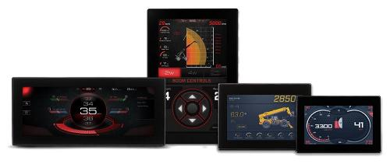

**DISPLAY  
CONFIGURE  
CONTROL**

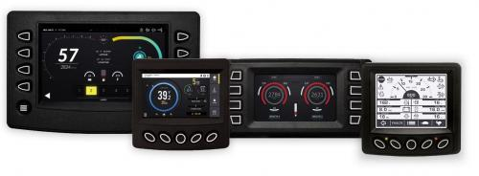

**MURCAL INC.**

**FIRMWARE VERSION: 1.0.0 (04/15/2024)**

**WWW.MURCAL.COM (661) 272-4700**

**Table of Contents**

**INTRODUCTION** 3

**CARE AND MAINTENANCE** 3

**OPERATION:** 4

**SCREENS & FLOWS** 4

**PAGES** 7

**GAUGE PAGES** 7

**QUICK ACCESS (POPOUT)** 8

**PASSCODE ENTRY** 8

**CAMERAS** 9

**BRIGHTNESS (DAY / NIGHT MODE)** 9

**SERVICE REMINDERS** 10

**EMISSIONS** 11

**TRIP INFORMATION** 12

**ALARMS AND CODES** 12

**HIDE / SHOW FAULTS** 13

**MULTIPLE MESSAGES** 13

**DATALOGGING** 13

**MENUS AND SETTINGS** 14

**ENGINE** 14

**INPUTS / OUTPUTS** 15

**SERVICE** 18

**COMMUNICATION** 19

**GAUGE CONFIGURATION** 20

**INSTALLATION & ACCESSORIES** 22

**DISPLAY PINOUT** 22

# **INTRODUCTION**

The PowerView 700 is a full-color configurable display that integrates vital engine, transmission, and diagnostic information into an easy-to-read operator interface. The PV700 is easily viewed in full sunlight and contains an optically bonded LCD inside its IP67-rated case to keep it safe in all-weather environments. The PV700's high-speed processor allows it to boot quickly as well as seamlessly showcase graphics, transitions and videos and its available glove-friendly touchscreen and rugged design make it a perfect solution for all types of environments and applications.

# **CARE AND MAINTENANCE**

General maintenance is not required: however, it is recommended to use a soft cloth for cleaning the unit. Window cleaner or alcohol can also be used to clean the glass portion of the display. Do not use harsh or abrasive cleaners on the unit.

# **OPERATION:**

## **SCREENS & FLOWS**

The Gauge Display screen consists of several predefined layouts that contain combinations of analog gauges and straight bar gauges.

These screens are displayed upon startup. To scroll through the various gauge screens, press the Navigation Button soft keys. This can be repeated until all screens have been viewed. The currently displayed screen will stay active until another key is pressed.

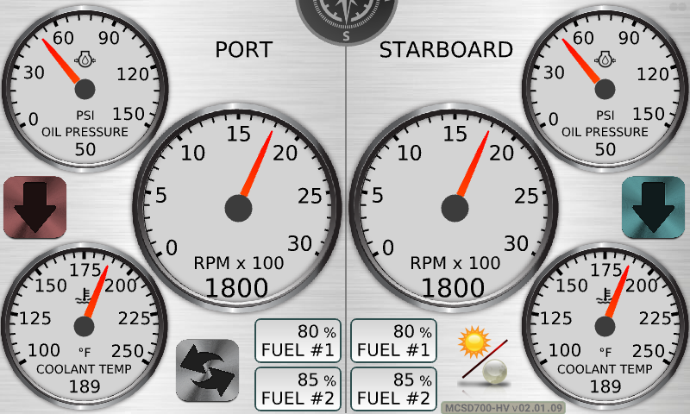

Image 1: PV700 Main Screen

Most gauge pages with analog and/or linear gauges, can typically be configured to display a variety of parameters from the CAN bus, gauges can also be hidden or shown from view to reduce clutter on pages.

**WARNINGS / ALARMS**

**MENUS / EDITORS**

**QUICK ACCESS**

**GAUGE PAGES**

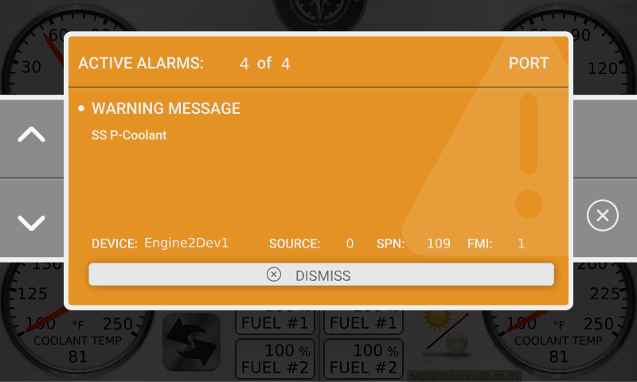

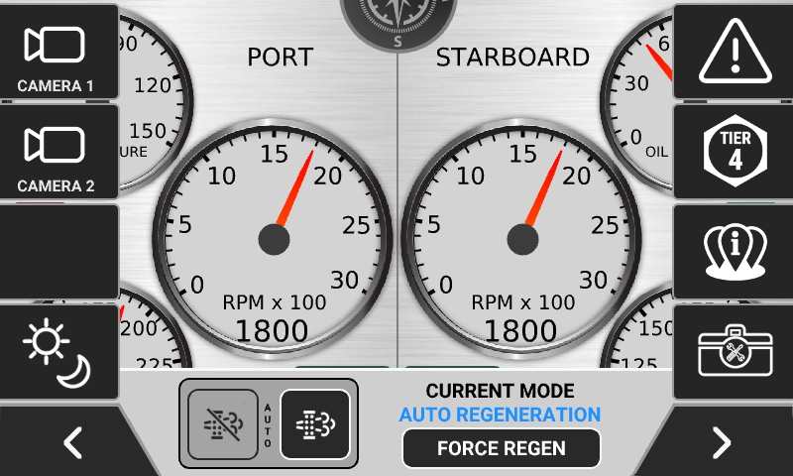

**GAUGE PAGES**

## **PAGES**

### **GAUGE PAGES**

On the gauge pages the marked gauge can be configured with their gauge configuration setting or disabled.

Image 2: Main Page Sections Description

The gauge pages options available to set each gauge are listed in the table below

|  |  |
| --- | --- |
| Dial Gauges | Bar Gauges |
| Disabled  Engine Oil Pressure  Coolant Temperature  Engine Load % at RPM  Alternator Potential Voltage  Battery Potential Voltage  Display Voltage  Transmission Oil Temp | **Disabled**  **Engine Load % at RPM**  **P-Charge Air**  **Transmission Oil Pressure** |

# **QUICK ACCESS (POPOUT)**

The quick access menu is a menu accessed by touching the screen anywhere outside of the navigation buttons, this menu allows you to access the passcode entry for the main menu, and hotkeys to some additional functionality.

## **PASSCODE ENTRY**

There are three security tiers within the display, low / medium / high, these passcodes are not end user settable.

**Low Security:** 1234

Low Security allows an operator to reach the basics of the display menu system, and is useful for service reminders

**Medium Security:** 5678

Medium Security allows an operator to reach the basics of the display menu system, including gauge configurability, but not engine or I/O settings.

**High Security:** 3482

High Security allows an operator to reach every setpoint available in the display menu system.

## **CAMERAS**

The display is setup to work with three (3) NTSC compliant video cameras, only a single video feed can be displayed at a time, and which camera is displayed is based on the camera input selected.

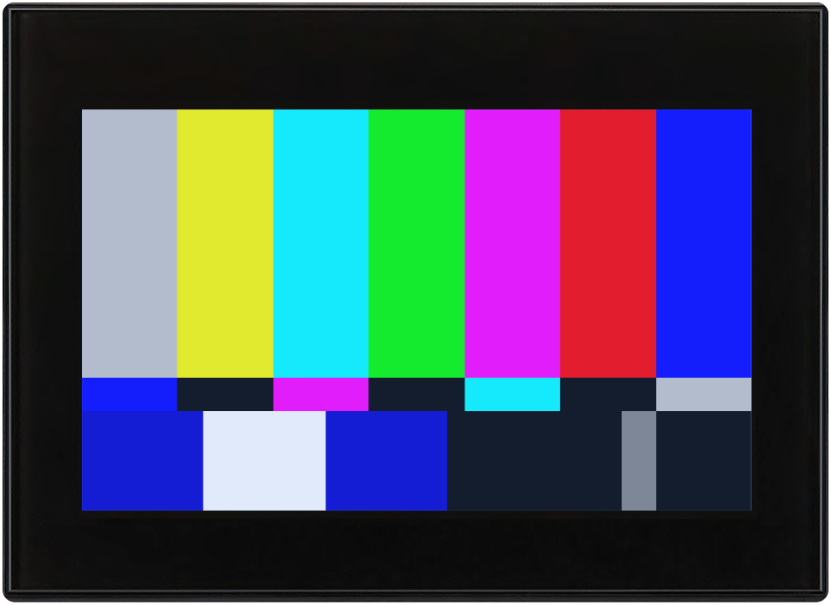

To exit from any camera view, simply touch the screen.

If the backup camera option has been enabled in the menu’s, Camera 3 is used and the screen will switch to this view if any of the J1939 Transmission Current Gear is read as being in reverse, it will switch back to the main gauge page when the transmission is not in reverse.

## **BRIGHTNESS (DAY / NIGHT MODE)**

The Day / Night Mode popup allows you to change and save the brightness for Day Mode, as well as Night Mode, and allows you to toggle between two brightness’s.

## **SERVICE REMINDERS**

The service reminders popup shows your six configurable service reminders, and how many hours are left until service is due, to reset any service reminder, enter the main menu using any security code, navigate to service reminders, and reset each reminder.

## **EMISSIONS**

The toggle button, on the left-hand side of the popup, allows you to change from Auto Regeneration to Inhibit Regeneration. If you have inhibited regeneration and wish to manually force a regen process, touch the Force Regen button and a regen message will be broadcast.

## **TRIP INFORMATION**

Trip statistics keeps track of Trip Fuel Used, Time Since Last Trip Reset, and Total Fuel Used. To clear Trip Fuel Used and Trip Hours, simply press Reset Trip.

## **ALARMS AND CODES**

A fault condition will trigger a popup dialog box on the screen describing the nature of the fault. Corresponding red or amber fault lights on the corners of the unit are also activated to indicate the severity of the fault. The following screen is an example of warning fault code popup.

A yellow / amber background indicates a warning.

A red background indicates a failure or fault.

### **HIDE / SHOW FAULTS**

To hide the fault code popup being displayed on the screen, press the key on the right, or the dismiss bar. The popup will disappear, however the Warning or Stop icon will remain on the screen to indicate there is still a fault. Pressing Hide does not clear the fault; it only hides the popup message. When a fault code has been hidden, a Recall icon will remain on the right side. When this soft key is pressed, the fault code will again be displayed.

When a fault code has been hidden, a Recall icon will remain on the right side. When this soft key is pressed, the fault code will again be displayed. When a popup message has been activated, a pop-up message will be displayed until the alarm is acknowledged by pressing the Hide key.

### **MULTIPLE MESSAGES**

The title-bar of the fault code popup may indicate multiple messages, as in Diagnostic Message 1 of 3. Press the Up and Down keys to scroll through the different messages.

### **DATALOGGING**

The display internally data logs two log files, one is a recurring / rolling log on a fixed interval, the other is a conditional snapshot logger that is taken when a fault condition happens.

The name of the recurring / rolling log is IntervalLog.csv, the conditional log is titled SnapshotLog.csv

* Interval Logging
  + Data is logged on a 1 second interval
  + When out of space, old log entries are deleted, and new entries appended
  + A timestamp will be present if the hardware supports a Real Time Clock.
* Snapshot Logging
  + Data is logged on a 1 second interval
  + 120 seconds worth of logs are kept
  + Triggers when any DM1 message SPN / FMI is received by the display from the engine or like device.

# **MENUS AND SETTINGS**

## **ENGINE**

|  |  |  |  |
| --- | --- | --- | --- |
| Name | Range | Default | Description |
| Engine#1 Manufacturer | Caterpillar (M-T4F)  Cummins (M-T4F)  John Deere (M-T4F)  Deutz (M-T4F)  Kohler KDI 1903  Kubota (M-T4i, Gaseous)  JCB (T4F)  Volvo (T3-T4F)  FPT (T4F)  Isuzu (M)  PSI (EControls ECU)  Ford (EControls ECU)  GM (MEFI ECU)  Scania (T3-T4F)  Perkins (M-T4F)  Hatz (M-T4F)  Yanmar (T4F)  Kohler KDI 1903  Kubota (M-T4F. T4F DOC Only)  Kubota (Gaseous)  Doosan  MTU/Daimler  Other | Other | Allows the selection of the specific engine manufacturer, this setting also addresses engine manufacturer ~~specific TSC1 throttle,~~ icons and T4F requirements |
| Engine#1 Emission | Tier 3 or less  Interim Tier 4  Tier 4 / EU Stage IIIA/B IV | Tier 3 or Less | Allows the user to manually override the Engine Manufacturer preset selections of engine emissions |
| Engine#2 Manufacturer | (listed above) | Other | Specified above. |
| Engine#2 Emission | (listed above) | Tier 3 or Less | Specified above. |
| Tier 4 Regeneration |  |  | Future |
| Speed Source |  |  | Future |
| Speed Calibration |  |  | Future |
| DPF or SCR |  |  | Future |
| Engine#1 J1939 Address(0) Address | 0 – 255 | 0 | Allows the operator to set the source address of the ECU the display is connecting to. Normally set to 0, 1 or 2 per SAE J1939 specifications. |
| Engine#1 J1939 Address(1) Address | 0 – 255 | 1 | Specified above. |
| Engine#1 J1939 AddressCB2 | 0 – 255 | 0 | Specified above. |
| Engine Configuration | Single Engine CANPort #1 / Dual Engine CANPort #1 / Dual Engine Both CANPorts | Dual Engine CANPort #1 | Specify the port configuration for your engines. |
| Hour Select | Engine ECU / Display - Internally | Engine ECU | Future |

## **INPUTS / OUTPUTS**

| Name | Range | Default | Description |
| --- | --- | --- | --- |
| Digital Inputs |  |  |  |
| Digital Input 1 |  |  |  |
| Input On/Off | Off/ On | On | --- |
| Alarm On/Off | Off/ On | On | --- |
| Alarm Delay | 0 – 60 Sec | 5 Sec | Set how long to wait before alarming, this is a self-resetting delay. |
| Alarm Type | None / Action / Warning /  Shutdown | Warning | Set which type of alarm |
| Alarm Warning/Shutdown Text | 0 – 50 Characters | No Label | Allows the user to enter a text string of their own choosing, which displays to an operator when the alarm is triggered |
| Lockout On/Off | Off/ On | Off | --- |
| Lockout Delay | 0 – 60 Sec | 5 Sec | --- |
| Lockout RPM | 0 – 3000 RPM | 0 RPM | --- |
| Active On/Off | Off / On | Off | Enable if the digital input should turn on a digital output when active |
| Action Output | Aux 1 / Aux 2 / Aux 3 / Aux 4 | Aux 1 | Set which digital output turns on when the digital input is active |
| Digital Input 2 | (Specified above) |  |  |
| Digital Input 3 | (Specified above) |  |  |
| Digital Input 4 | (Specified above) |  |  |
| Digital Input 5 | (Specified above) |  |  |

|  |  |  |  |
| --- | --- | --- | --- |
| Name | Range | Default | Description |
| Digital Outputs |  |  |  |
| Digital Output 1 |  |  |  |
| Enabled | Disabled  Enabled | Enabled | Set whether you are using the output |
| Function | Warning  Shutdown  Common Alarm  Output 1 | Output | Select what the output should do |

|  |  |  |  |
| --- | --- | --- | --- |
| Name | Range | Default | Description |
| Analog Inputs |  |  |  |
| Analog Input 1 |  |  |  |
| Active | Disabled  Enabled | Enabled | Set whether you are using the input |
| Quickset | Eng Oil Press – Datcon  Eng Oil Press - Murphy  Eng Oil Press – VDO 5 Bar  Eng Oil Press – VDO 7 Bar  Eng Cool. Temp – Datcon  Eng Cool. Temp – Murphy  Eng Cool. Temp – VDO  Eng Fuel Level – Datcon  Eng Fuel Level – Murphy  Eng Fuel Level – VDO  Eng Oil Press – 0-5 VDC  Eng Cool. Temp – 0-5 VDC  Eng Fuel Level – 0-5 VDC  Gear Oil Press – 0-5 VDC  Gear Oil Temp – 0-5 VDC  Eng Oil Temp – 0-5 VDC  Eng Oil Press – 4-20mA  Eng Cool. Temp – 4-20mA  Eng Fuel Level – 4-20mA  Gear Oil Press – 4-20mA  Gear Oil Temp – 4-20mA  Eng Oil Temp – 4-20mA  Engine Throttle Control – 4-20mA | Engine Throttle Control – 4-20mA | Select what the analog input should be, a custom defined table, or a sensor already pre-entered.  (Future) |
| Warnings |  |  |  |
| Low Enabled | Enabled  Disabled | Disabled |  |
| Low Setpoint | 0 – 9999.99 | 0 |  |
| Low Label | 0 – 50 Characters | No Label | Allows the user to enter a text string of their own choosing, which displays to an operator when the alarm is triggered |
| High Enabled | Enabled  Disabled | Disabled |  |
| High Setpoint | 0 – 9999.99 | 0 |  |
| High Label | 0 – 50 Characters | No Label | Allows the user to enter a text string of their own choosing, which displays to an operator when the alarm is triggered |
| Shutdowns |  |  |  |
| Low Enabled | Enabled  Disabled | Disabled |  |
| Low Setpoint | 0 – 9999.99 | 0 |  |
| Low Label | 0 – 50 Characters | No Label | Allows the user to enter a text string of their own choosing, which displays to an operator when the alarm is triggered |
| High Enabled | Enabled  Disabled | Disabled |  |
| High Setpoint | 0 – 9999.99 | 0 |  |
| High Label | 0 – 50 Characters | No Label | Allows the user to enter a text string of their own choosing, which displays to an operator when the alarm is triggered |
| Lockout Delay | 0 – 600 Sec | 0 Sec | Set how long to wait before arming the alarms for the input |
| Lockout Variable | Engine RPM | Engine RPM |  |
| Analog Input 2 | (Specified above) |  |  |
| Analog Input 3 | (Specified above) |  |  |

## **SERVICE**

|  |  |  |  |
| --- | --- | --- | --- |
| Name | Range | Default | Description |
| Service Reminders |  |  |  |
| Reminder 01 |  |  |  |
| Reset | No  Yes | No | Select Yes to reset this service reminder |
| Hours | 0 - 9999 | 0 | Select how many hours before this service reminder alarms |
| Label | 0 – 50 Characters | No Label | Allows the user to enter a text string of their own choosing, which displays to an operator when the service reminder is triggered |
| Reminder 02 |  |  |  |
| Reset | No  Yes | No | Select Yes to reset this service reminder |
| Hours | 0 - 9999 | 0 | Select how many hours before this service reminder alarms |
| Label | 0 – 50 Characters | No Label | Allows the user to enter a text string of their own choosing, which displays to an operator when the service reminder is triggered |
| Reminder 03 |  |  |  |
| Reset | No  Yes | No | Select Yes to reset this service reminder |
| Hours | 0 - 9999 | 0 | Select how many hours before this service reminder alarms |
| Label | 0 – 50 Characters | No Label | Allows the user to enter a text string of their own choosing, which displays to an operator when the service reminder is triggered |
| Reminder 04 |  |  |  |
| Reset | No  Yes | No | Select Yes to reset this service reminder |
| Hours | 0 - 9999 | 0 | Select how many hours before this service reminder alarms |
| Label | 0 – 50 Characters | No Label | Allows the user to enter a text string of their own choosing, which displays to an operator when the service reminder is triggered |
| Reminder 05 |  |  |  |
| Reset | No  Yes | No | Select Yes to reset this service reminder |
| Hours | 0 - 9999 | 0 | Select how many hours before this service reminder alarms |
| Label | 0 – 50 Characters | No Label | Allows the user to enter a text string of their own choosing, which displays to an operator when the service reminder is triggered |
| Reminder 06 |  |  |  |
| Reset | No  Yes | No | Select Yes to reset this service reminder |
| Hours | 0 - 9999 | 0 | Select how many hours before this service reminder alarms |
| Label | 0 – 50 Characters | No Label | Allows the user to enter a text string of their own choosing, which displays to an operator when the service reminder is triggered |
| Reset All | No  Yes | No | Select Yes to reset all service reminders |

## **COMMUNICATION**

| Name | Range | Default | Description |
| --- | --- | --- | --- |
| Communication |  |  |  |
| CANPort 1 | --- | --- | --- |
| Terminating Resistor | Off  On | On | This setting allows you to enable or disable a 120 Ohm terminating resistor on the CANbus |
| Baud Rate | 1 kbps  10 kbps  20 kbps  50 kbps  100 kbps  125 kbps  250 kbps  500 kbps  800 kbps  1000 kbps | 250 kbps | The baud rate of the CANPort, 250 kbps is typical for industrial and stationary engines, 500 kbps is typical for industrial vehicles / buses etc. |
| Source Address | 0 – 255 | 43 | The source address the display claims on the CANbus |
| CANPort 2 | --- | --- | --- |
| Instance ID | 0 – 255 | 0 | The NMEA 2000 Engine ID |
| Terminating Resistor | Off  On | On | This setting allows you to enable or disable a 120 Ohm terminating resistor on the CANbus |
| Baud Rate | 1 kbps  10 kbps  20 kbps  50 kbps  100 kbps  125 kbps  250 kbps  500 kbps  800 kbps  1000 kbps | 250 kbps | The baud rate of the CANPort, 250 kbps is typical for industrial and stationary engines, 500 kbps is typical for industrial vehicles / buses etc. |
| Source Address | 0 – 255 | 141 | The source address the display claims on the CANbus |
| Reverse Camera(3) | Disabled / Enabled | Disabled | Disable or Enable the Camera#3 as a Backup Camera. |

## **GAUGE CONFIGURATION**

| Name | Range | Default | Description |
| --- | --- | --- | --- |
| Gauge Configuration |  |  |  |
| Port Gauges | --- | --- | --- |
| Left Top Gauge | Disabled  Engine Oil Pressure  Coolant Temperature  Engine Load  Alternator Potential Voltage  Battery Potential Voltage  Electrical Potential Voltage  Transmission Oil Temp | Engine Oil Pressure | Select which parameter to display for this gauge.  Note 1: If you are not seeing battery voltage, try out both Alternator Potential Voltage and Battery Potential Voltage, different engine manufacturers map battery voltage to different SAE J1939 parameters.  Note 2: For detailed information as to what SAE J1939 parameter these items refer too, see the appendix. |
| Left Btm Gauge | (Specified Above) | Transmission Oil Pressure | Specified above. |
| Right Top Gauge | (Specified Above) | Coolant Temperature | Specified above. |
| Right Btm Gauge | (Specified Above) | Battery Potential Voltage | Specified above. |
| Left Bar Gauge | Disabled  Engine Load  P-Charge Air  Transmission Oil Pressure | Engine Load | Select which parameter to display for this gauge. |
| Right Bar Gauge | Disabled  Engine Load  P-Charge Air  Transmission Oil Pressure | P-Charge Air | Select which parameter to display for this gauge. |
| Starboard Gauges | --- | --- | --- |
| Left Top Gauge | Disabled  Engine Oil Pressure  Coolant Temperature  Engine Load  Alternator Potential Voltage  Battery Potential Voltage  Electrical Potential Voltage  Transmission Oil Temp | Engine Oil Pressure | Select which parameter to display for this gauge.  Note 1: If you are not seeing battery voltage, try out both Alternator Potential Voltage and Battery Potential Voltage, different engine manufacturers map battery voltage to different SAE J1939 parameters.  Note 2: For detailed information as to what SAE J1939 parameter these items refer too, see the appendix. |
| Left Btm Gauge | (Specified Above) | Transmission Oil Pressure | Specified above. |
| Right Top Gauge | (Specified Above) | Coolant Temperature | Specified above. |
| Right Btm Gauge | (Specified Above) | Battery Potential Voltage | Specified above. |
| Left Bar Gauge | Disabled  Engine Load  P-Charge Air  Transmission Oil Pressure | Engine Load | Select which parameter to display for this gauge. |
| Right Bar Gauge | Disabled  Engine Load  P-Charge Air  Transmission Oil Pressure | P-Charge Air | Select which parameter to display for this gauge. |

# **INSTALLATION & ACCESSORIES**

### **DISPLAY PINOUT**

|  |  |  |
| --- | --- | --- |
| Black Connector | |  |
| 1 | Digital Input 1 |
| 2 | Analog Input 3 + |
| 3 | Analog Input 2 + |
| 4 | Analog Input 1 + |
| 5 | CAN1 Low |
| 6 | CAN1High |
| 7 | Battery |
| 8 | Ground |
| 9 | Analog Input 3 - |
| 10 | Analog Input 2 - |
| 11 | Analog Input 1 - |
| 12 | Digital Input 3 |
| 13 | Digital Input 2 |
| 14 | Frequency Output 1 |
| 15 | Ignition On |
| 16 | NA |
| 17 | NA |
| 18 | CAN2 Low |
| 19 | CAN2High |
| 20 | Digital Input 4 |
| 21 | Digital Input 5 |
| 22 | Digital Output |
| 23 | Frequency Output 2 |

|  |  |  |
| --- | --- | --- |
| Black Connector | |  |
| 1 | Frequency In |
| 2 | NA |
| 3 | NA |
| 4 | Video 4 In P |
| 5 | Video 3 In P |
| 6 | Video 2 In P |
| 7 | Video 1 In P |
| 8 | NA |
| 9 | Frequency In Return |
| 10 | 12 VDC Output |
| 11 | Video 4 In N |
| 12 | Video 3 In N |
| 13 | Video 2 In N |
| 14 | Video 1 In N |
| 15 | NA |
| 16 | NA |
| 17 | NA |
| 18 | NA |
| 19 | NA |
| 20 | NA |
| 21 | NA |
| 22 | NA |
| 23 | NA |